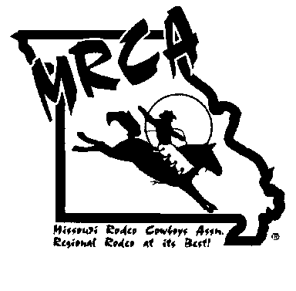**MRCA 2025 Membership Application**

# All Contesting Members Must Be Missouri Residents. Contestant cards are **$110.00. Contestant cards can be purchased at any time before the cutoff for the finals, however all contestants must enter a minimum of 4 approved rodeos to be eligible to compete at the finals.** Personal cards are $55 must be purchased by August1st, paid to the Missouri Rodeo Cowboy Association, Inc. . All memberships become delinquent after December 31st. **IF YOU ARE UNDER 18 YOUR APPLICATION MUST HAVE A PARENT’S SIGNATURE NOTARIZED. YOUR MEMBERSHIP WILL NOT BE VALID UNTIL THIS IS RECEIVED. THIS MUST BE DONE EVERY YEAR.**

Return to: Kari Mason MRCA Secretary ~ 19962 Magnolia Ave, Marshall, MO 65340 ~ [mrcasecretary23@gmail.com](mailto:mrca.secretary@gmail.com)

**Check all that apply: Contestant Personnel New Renewal Gold Card Member**

*Please Print:* **Card Number** County Name Address City State Zip Phone Birthdate

# Email Circle Jacket Size XS S M L XL XXL XXXL

**Circle event:** BB SB BR CR O40CR SW GBR TR header TR heeler BKWY

**Circle Personnel Category:** Announcer Secretary Timer Judge P/U Man Bullfighter Other

**$25 Associate Membership: *(****Does not allow any benefits for awards or hire at any MRCA event.)*

# Payment Cash Check Money Order Total Paid:

*A* ***$5.00 service charge*** *will be added to all payments made by Credit Card. Include all charges in the total paid balance.*

# Visa Mastercard Discover Card No: Expiration Date: CVC: Name as on the Card: Cardholder Signature:

MO Drivers License No. *MUST Be Provided in Order to Issue a Contestant Card*

# Signature Social Security No:

I certify the above information to be correct, as a member of the MRCA, I agree to abide by all rules, by-laws and regulations at all MRCA sanctioned and co-sanctioned events. I will not hold the MRCA or any of its affiliates liable for property damage or injury.

***All Applicants under 18 years of age must complete the following. This must be notarized and returned to the MRCA.***

The undersigned (including the undersigned’s parent or legal guardian if the undersigned is under the age of 18) hereby assumes the risks inherent in all rodeo or other equine-related activities, including without limitation, all physical or other injury to the undersigned and all accident, injury or damage to any horse owned, leased, ridden, handled or otherwise under the care and responsibility of the undersigned (the “Activities”). The undersigned hereby agrees to release, hold harmless and indemnify the **MISSOURI RODEO COWBOY ASSOCIATION, INC.** (“MRCA”) and all employees, directors, officers, agents and affiliates of the MRCA (collectively, the “Indemnity(ies)”) to the full extent authorized or permitted by applicable law, which indemnification shall include but not be limited to any and all expenses (including attorneys’ fees), judgments, fines and amounts paid in settlement incurred by Indemnities in connection with any proceeding arising as a result of or relating to or in connection with the Activities to which any Indemnity is, was or at any time becomes a party, or is threatened to be made a party. The extent of the indemnification provided hereunder shall be expanded whenever necessary to provide Indemnities with indemnification to the fullest extent permitted by applicable law in the event such law may change or develop in the future, but in no event shall the extent of indemnification be less than the fullest extent permissible under applicable law as in existence at the time the Agreement is executed.

# Parent/Guardian Consent:

I certify that the age and date of birth of the below named person is correct, and I hereby consent to their participation in the Missouri Rodeo Cowboy Association, Inc. I agree that in no event will I hold the MRCA, it’s agents or employees liable for injury or property damage while participating at a rodeo or while en route to or from a MRCA sanctioned event.

APPLICANT BIRTHDATE AGE ADDRESS DATE CITY/STATE/ZIP PARENT/GUARDIAN SIGNATURE

The Foregoing instrument was acknowledged before me this day by parent, guardian, and/or above applicant, and I certify that the above information is true to the best of my knowledge.

**Notary Public Date My commission expires**

MRCA Form 114A (11/12)